**Members:**

Balcena, Danya P.

Gardon, Jana Marie G.

General, Jeri Luther

**Project Title:**

**Road Tweet**

**Description:**

Road Tweet is a mobile application that enables the user to inform the people about the condition of destination they wanted to know either there is a traffic or not and either there are long queues in the terminals through “tweets”. Anything related to roads only may be posted here. The application also let the users create a profile with a profile picture and their basic information. They can also register for an account for the Road Tweet. Registered users can post and read traffic tweets and each tweets may also include photos or videos to avoid confusion as well. It is assumed that all tweets are public so that everyone can be informed about the condition of a particular location.

**Objectives:**

Our objectives are to help people from avoiding the traffic, help the people to get to their location fast and safe and to help them avoid from the accident.

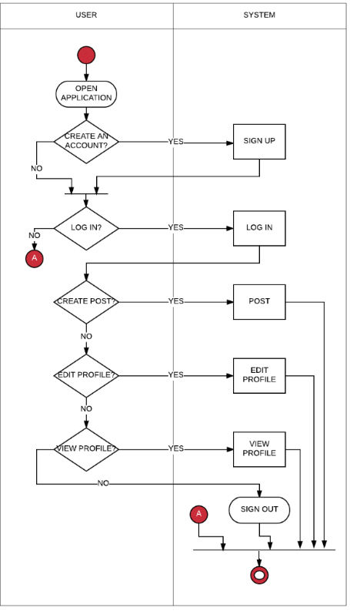**Activity Diagram:**

**Interface:**

**Main Activity Sign-Up Activity**

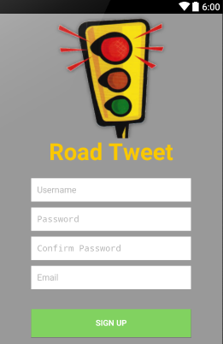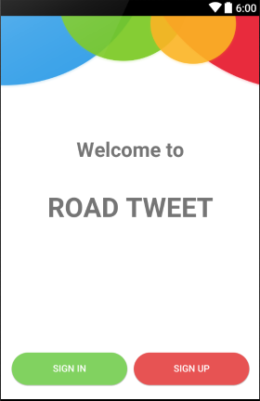

**Sign-in Activity Options Activity**

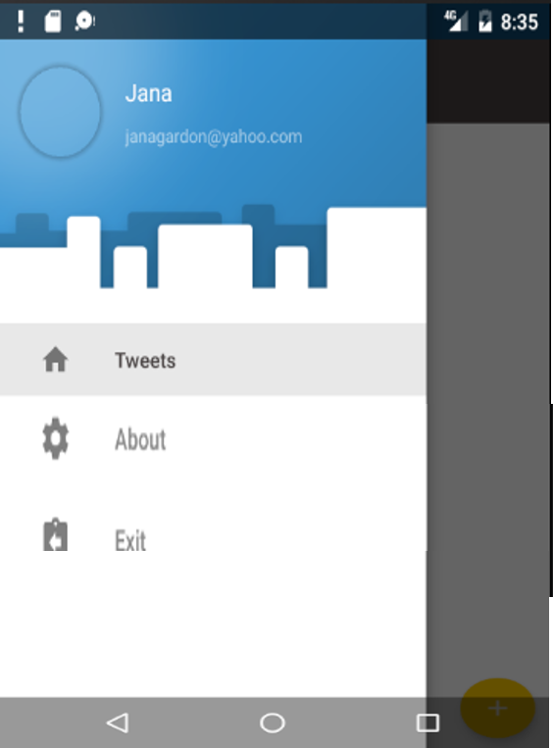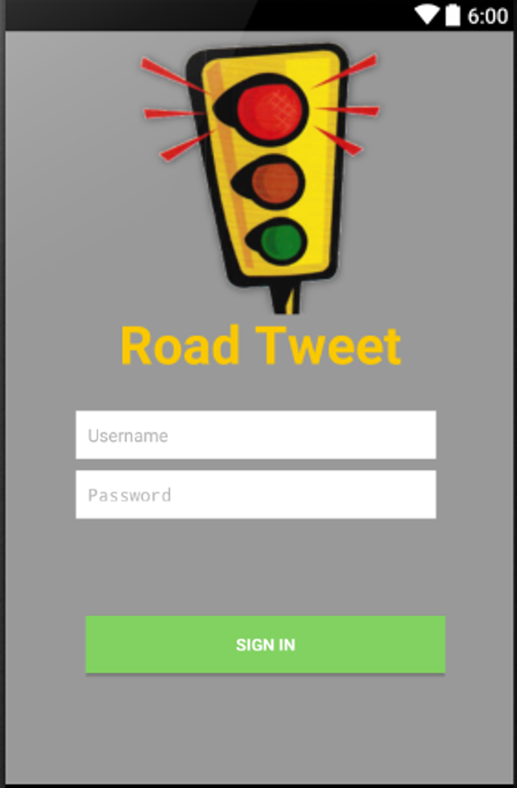

**Publish Activity User Profile Activity**

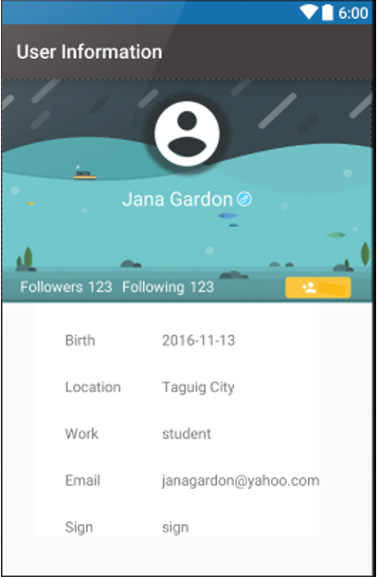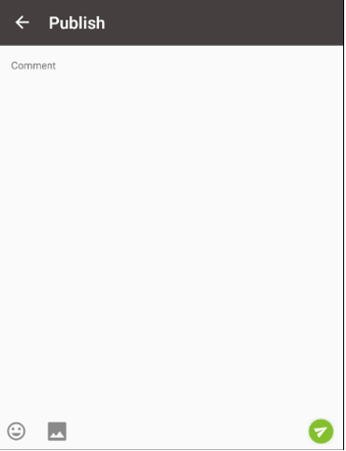

**Add information**

